**Task #1**

**1- What is Cloud Computing and what is type of them?... 2- What are major cloud service/deployment models? Can you provide an example of each?**

Cloud computing is computing over the internet, which has service consists of highly optimized virtual data centers that provide various software and hardware and information resources for use when needed.[1]

* Just, the organization connected to cloud computing and used the available resources of it with a pay per use basis. [1]

### Types of cloud services

**Software as a service (SaaS**): a method for delivering software applications over the Internet as per the demand and on a subscription basis (helps you host and manage the software application and underlying infrastructure)

such as data, middleware, servers, and storage

**Platform as a service (PaaS):** refers to the supply of an on-demand environment for developing, testing, delivering and managing software applications (designed to quickly create web/mobile apps)

such as scalability, multi-tenancy, elasticity

**Functions as a service (FaaS**): adds another layer of abstraction to PaaS, so that developers are completely insulated from everything in the stack below their code. Instead of handling the hassles of virtual servers, containers, and application runtimes, they upload narrowly functional blocks of code and set them to be triggered by a certain event

**Infrastructure-as-a-service (IaaS)** most basic category of cloud computing services that allows you to rent IT infrastructure (servers for VMs) from a cloud provider on a pay-as-you-go basis

such as storage, networking, and virtualization.

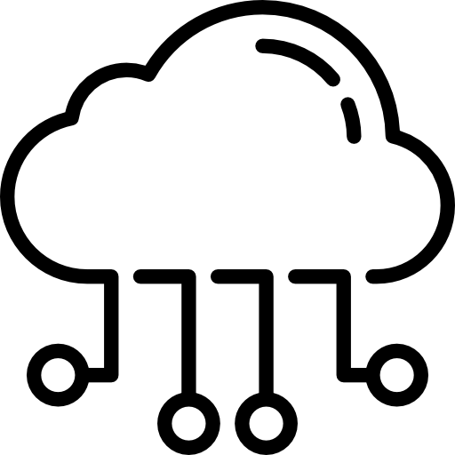

Cloud

**Private Cloud**:

* One Organization
* Private Network
* Highly Secure

**Public Cloud**:

* Owned by the cloud service provider
* Highest of Efficiency
* Share resources

**Hybrid Cloud**:

* Combination of Private &Public Models
* Use a specific resources "Used in Public" and Use on-premises "used in Private"







**Cloud Computing Deployment Models**

**3- what OpenStack cloud?**

OpenStack is a cloud operating system (the dashboard is also available giving administrators control) that controls large pools of computing, storage, and networking resources throughout a data center, all managed and provisioned through APIs with common authentication mechanisms.[3]

**4-What is AWS?[4]**

* AWS is one of the premier cloud providers, which is drastically changing the way many think about IT.
* AWS will provide you with remote access to a nearly unlimited supply of storage, compute, and database resources for an hourly price

**5 -what difference between OpenStack and AWS ?[5]**

|  |  |  |
| --- | --- | --- |
| **Offered Service** | **AWS** | **OpenStack** |
| Elasticity | Auto Scaling is a part of AWS | Autoscaling wit Heat |
| Virtual servers | based on EC2 | Based on Instance in Nova |
| Workflow Service | Follows Simple Workflow Service (SWF) | It has the Mistral – Workflow Service |
| Business Productivity Tools | Amazon WorkDocs | None |
| Workload Management | ELB (Elastic Load Balancer) | Load Balancer as a Service (LBaaS) |
| Billing | AWS Usage and Billing Report | Ceilometer – Telemetry based billing, resource tracking etc |
| Search Service | Elasticsearch Service | Searchlight |
| Database (NoSQL) | DynamoDB | Trove |
| Serverless Framework | Lambda | No Serverless Framework |
| SAN Data Storage | EBS(Elastic Block Storage) | Cinder |

**Task #2   
  
1-Register in AWS and create Instance**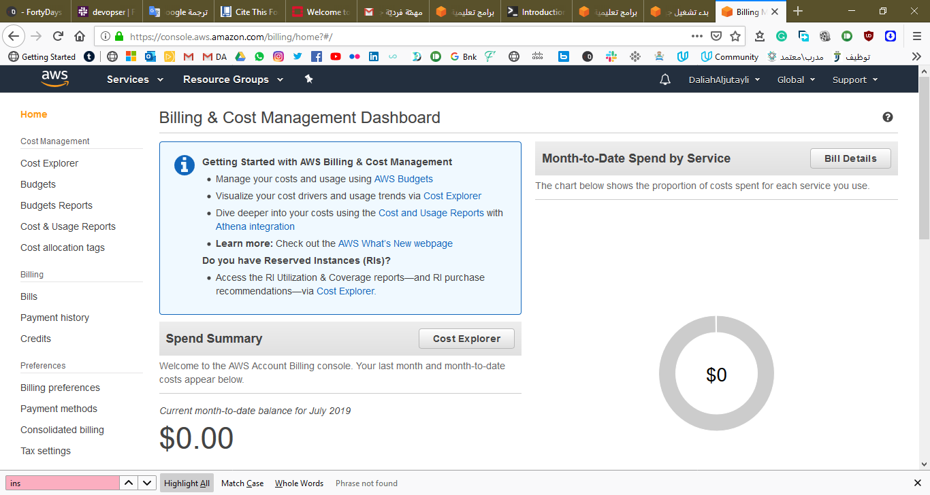

**2- making it ( Instance ) public instance   
  
3-Connect to Linux Instance using SSH and install Nginx on it. so if you visit IP address on the browser this will be appear “ welcome page for nginx”**

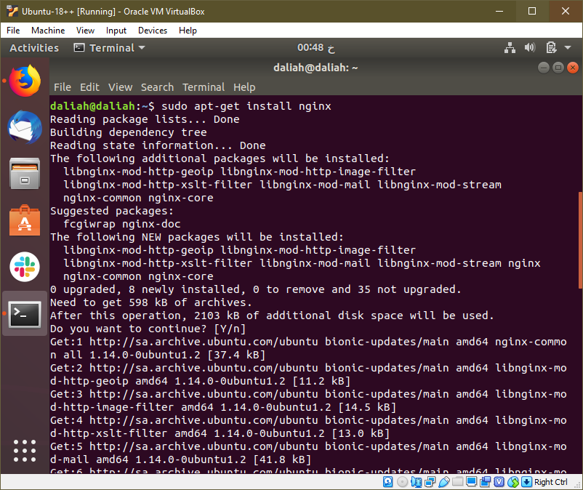

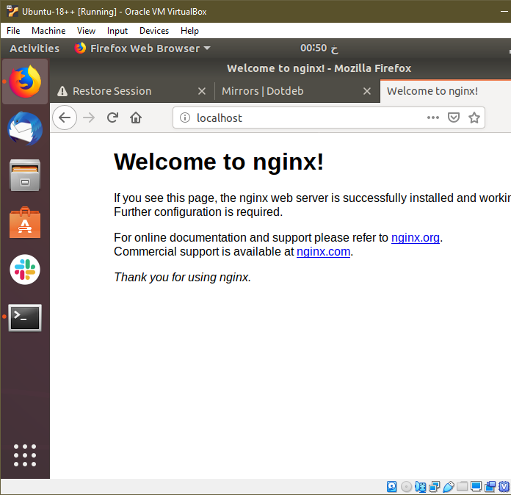

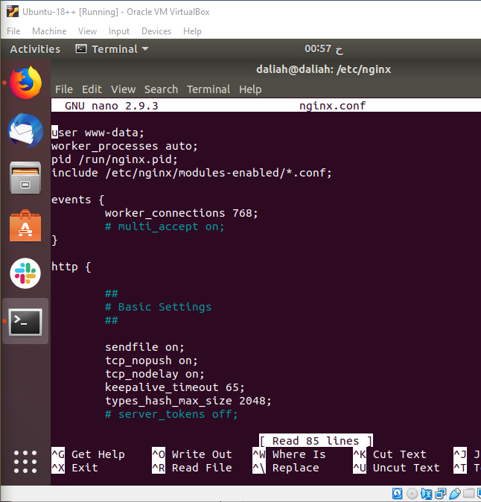

**==========================================**

**Task #3  
  
1-Register in OpenStack**

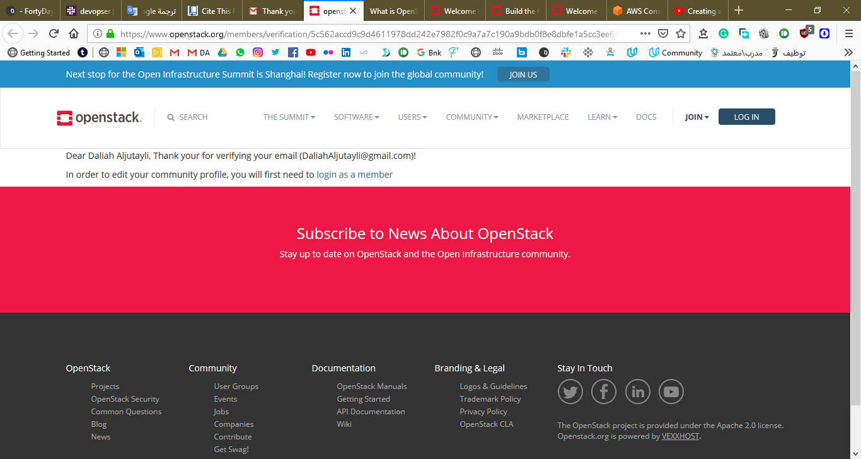

**2-Apply the same previous steps that you did on AWS  
  
3-After using the two platforms (AWS and OpenStack ) ,what are your comments or opinions?**

[1]"Cloud Computing: What is Cloud Computing?", *YouTube*, 2019. [Online]. Available: https://www.youtube.com/watch?v=uYGQcmZUTaw. [Accessed: 17- Jul- 2019].

[2]"Cloud Computing – Types of Cloud", *Esds.co.in*, 2019. [Online]. Available: https://www.esds.co.in/blog/cloud-computing-types-cloud/#sthash.z5avyl5H.dpbs. [Accessed: 17- Jul- 2019].

[3]"What is OpenStack?", *OpenStack*, 2019. [Online]. Available: https://www.openstack.org/software/. [Accessed: 17- Jul- 2019].

[4]"Introduction to Amazon Web Services (AWS)", *Sysadmincasts.com*, 2019. [Online]. Available: https://sysadmincasts.com/episodes/29-introduction-to-amazon-web-services-aws. [Accessed: 17- Jul- 2019].

[5]A. R, "AWS Vs OpenStack | Difference Between AWS and OpenStack", *Besant Technologies | No.1 Training Institute in Chennai, Bangalore & Pune*, 2019. [Online]. Available: https://www.besanttechnologies.com/aws-vs-openstack. [Accessed: 17- Jul- 2019].